**AGG: Aggregate Extraction**

Aggregate extraction includes areas of current or past aggregate extraction where evidence of their removal is still identifiable. Visual identification criteria including the following: large light-coloured excavation pits, heavy industrial equipment, scree piles from debris removal, aggregate storage piles or stalls, transport activities (trucks, loading conveyors, etc.) and proximity to suggestive physiographic features (Oak Ridges Moraine, major water courses, surficial geology). Aggregate extraction can be on a large industrial scale or a small scale on private property identified by small areas of slope removal with evidence of aggregate piles. Land Classification for this category extended as far as there was evidence of influence on the landscape or other property markings (fences, roads, etc).

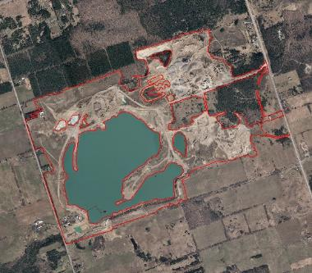

**AGR: Agriculture**

Agricultural areas are identified as areas that have current or recent evidence of cultivation or pasturing but will also include a residential building if present and all other structures or features relating to the agricultural operation.

Cultivation can be identified by the following visual indicators: till tracks (mechanized planting, harvesting), hay/stalk piles, manure spreading, freshly turned soils, rowed plant growth. Fallow fields should also be captured but it can be difficult to ascertain this status or to differentiate between a fallow field and a pasture or meadow. Using multiple years of imagery may assist in confirming this practice. If undertaking/performing an update to an existing layer a code change from ‘meadow’ to ‘agriculture’ should only be made if the area has clear visual indications of agricultural operations.

Small urban agricultural operations such as community farms are included.

Pasture areas are areas adjacent to horse paddocks, animal barns as evidenced by feed troughs, trampled areas, tracks and paths. These areas are different from meadows because they contain a combination of short grasses, some shrubs and are not fully naturalized.

Nursery operations that include greenhouses, small to large buildings, propagation fields, roadways, and parking.

Other landuse types such as ‘natural cover’ or ‘waterbodies’ should be isolated as described throughout.

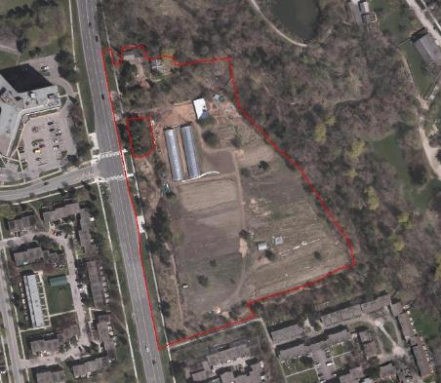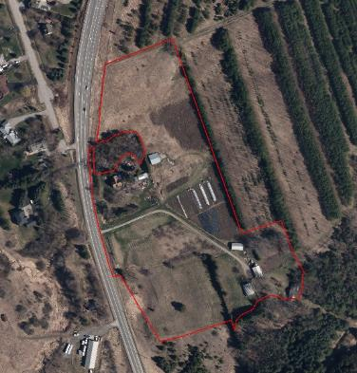

**AIR: Airport**

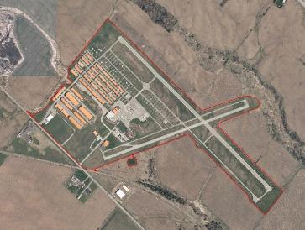Airports are visually identifiable primarily due to the existence of runway(s), hanger buildings, terminal buildings and visible aircraft on the ground. This class includes all of those features plus all of the property associated with the airport. The limit can be seen from fencing, roadways, natural barriers such as a watercourse or an obvious change in landuse condition to agriculture, residential or other. Heli-ports are included and are distinguished from industrial only by landing pads on either pavement, concrete or permeable surfaces. ‘Natural cover’ and ‘waterbodies’ should be isolated as described throughout.

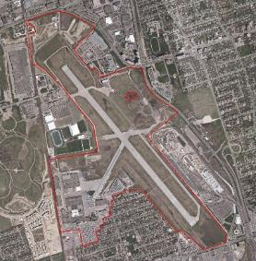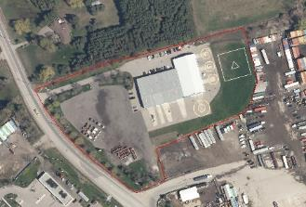

**CEM: Cemetery**

Visually, cemeteries appear as well manicured areas with visible grave markers, monuments, some trees, some buildings (could include a small church) and small winding roads.

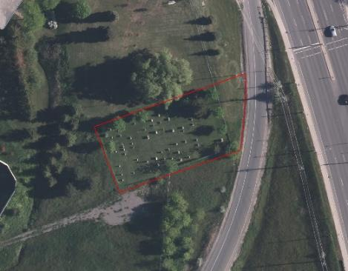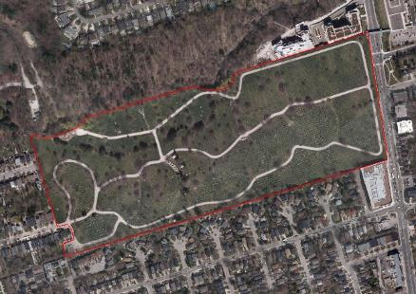

**COM: Commercial**

The ‘commercial’ class incorporates a wide variety of building types including box-store complexes, variety stores, restaurants, grocery stores, malls, plazas and office towers. Visual indicators for commercial areas included small to large parking lots, small to large buildings, flat paved roofs, proximity to street, level of road (arterial roads vs. residential or minor streets), shipping/receiving entryway, alleyways, rear parking and a lack of manicured areas.

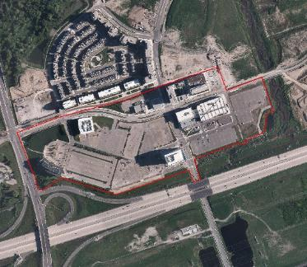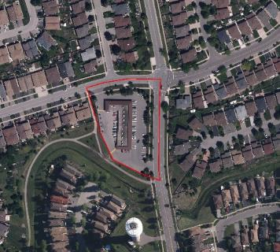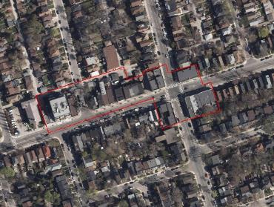Note: Multiple land use areas such as the existence of living quarters above stores/restaurants or a variety store at the base of an apartment building were grouped either under the ‘commercial’ class or ‘high density residential’, or ‘medium density residential’ respectively. The main reason is because it is often impossible to visually interpret these areas using the ortho images. As a result, this and all other land cover classifications were based on the most prominent/dominant land use for a given location.

**ESR: Estate Residential**

Very low density detached residential properties located within the urban or rural landscape with long private drives (sometimes circular or drive-through near the house) off of dedicated residential roads, concession roads and regional roads with at least several of the following additional criteria: large manicured lawn areas, small to large homes, private recreational areas (eg. tennis court, pool, patio), additional buildings, decorative landscaping. These areas often have natural areas or golf courses as surrounding uses.

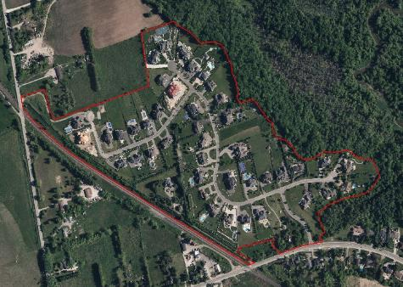

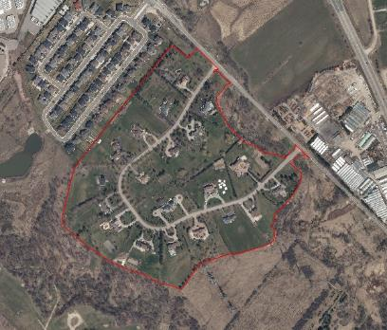

**GC: Golf Course**

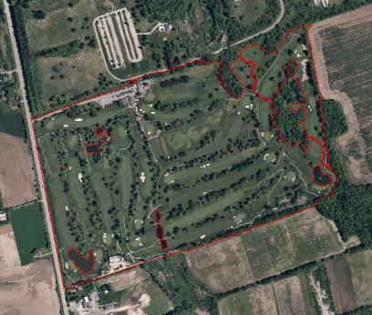Golf courses are often easily identifiable by visual interpretation – their unique manicured patterns and often bright green color contrasts with surrounding land areas. This class includes driving ranges, practice greens, mini-putts, all manicured areas of golf courses (greens, fairways), cart paths and all associated buildings (club house, maintenance, etc.). It does not include the ‘natural areas’ or ‘open water’ which should be isolated as described throughout.

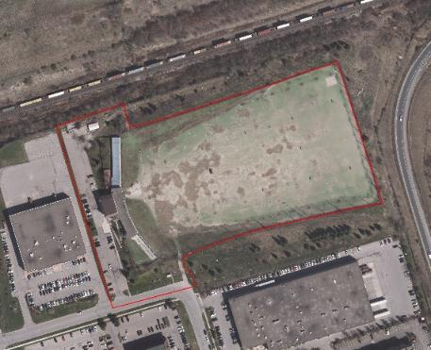

**HDR: High Density Residential**

High-rise apartment buildings and high density town house complexes in isolated subdivisions/contained development units with minimal to no existence of manicured lots visible, apartment and large condominium complexes and their associated property (includes small manicured areas and parking areas, if part of the complex). Open spaces and other landuses that meet the description of other classes should be separated as described throughout.

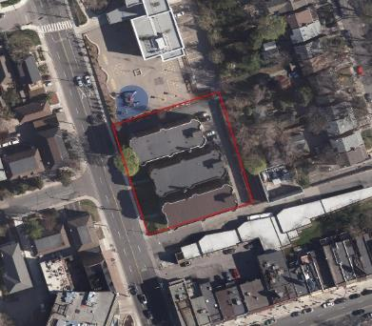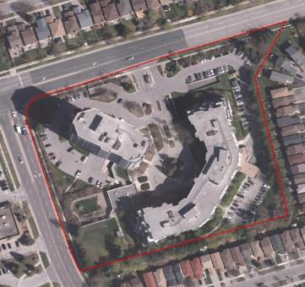

**IND: Industrial**

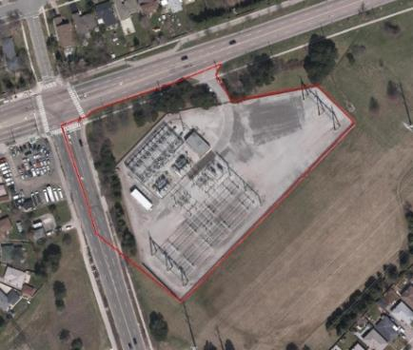Characterized by large warehouse and factory buildings with flat paved roofs which may or may not have integrated office space, plus associated manicured areas and parking, the existence of storage yards, scrap materials or automobile wreckers, transport truck storage, small amounts of dedicated railway track, hydro transfer or transformer stations are key indicators of these areas. Power generating stations are included in this class. Visual indicators of scrap material or auto wreckers are random, disorganized piles or rows of miscellaneous material, rows of vehicles on pervious surface, fencing and often with a main building plus possibly some additional “out” buildings. Dams and associated infrastructure and earthworks are included.

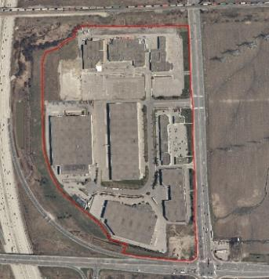

**INS: Institutional**

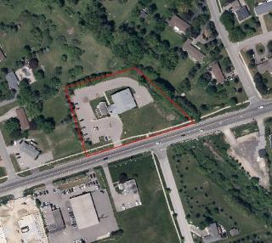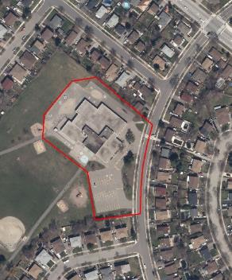Schools (including Universities and Colleges), conference centers, hospitals, dedicated church properties (see ‘Cemetery’ for further detail) and other facilities were classified as ‘Institutional’. A minimal amount of property associated with the institutional facility were included in the classified land area and was restricted to the parking lot, buildings and a small amount of pervious land surrounding these features. The balance of the ‘institutional’ parcel should be placed in to the ‘recreational and urban open space’ category as described.

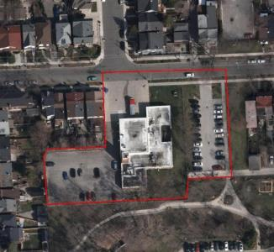

### **LDF: Landfill**

Areas of the landscape that are currently an active landfill site operation. Visual indicators of an active landfill site are exposed soil, machinery, internal roadways, gatehouse, gates and perimeter fencing. This can appear very similar to an aggregate pit but may have visible trash on the ground. The specific function of the site may only be known through local knowledge. This class will remain largely vacant until future active landfills are opened.

**MCE: Mixed Commercial Entertainment**

This class is targeted towards uses such as stadiums, large scale arenas, race tracks (animal or automobile), casinos, amusement parks, science centers, zoos, aquarium, historic villages/museums, permanent fairgrounds, equestrian parks. All of the property associated with the facility should be captured including, buildings, parking lots, internal roads, stables, concession stands. This class is only a small portion of the landscape so custom pervious values could be assigned to each polygon for modelling if desired.

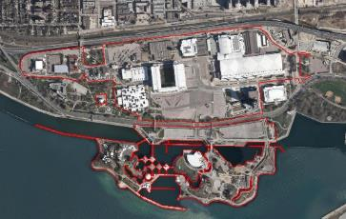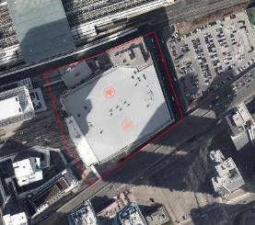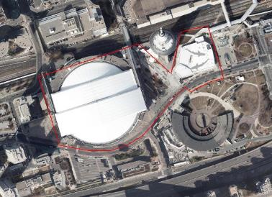

**MDR: Medium-Low Density Residential**

Classification range for the ‘medium-low density residential’ class is quite large. It includes lots for single detached homes with small to moderate manicured areas, semi-detached homes through to small town house complexes and small condominium complexes within mixed subdivisions and low-rise apartment buildings (less than 5 stories). Residential parcels that are part of rural communities such as villages and hamlets would also be part of this class. Open spaces and other landuses that meet the description of other classes should be separated as described throughout.

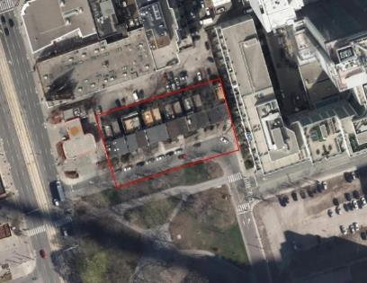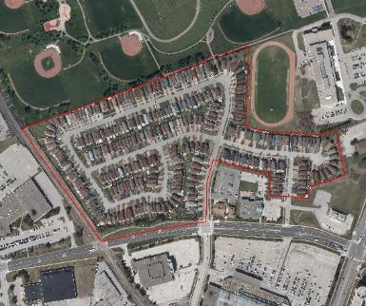

**NCB: Natural Cover - Beach/Bluff**

These are areas with limited vegetation and exposed sandy substrate. Sparse shrubs and grasses comprise a total of less than 50% vegetated cover. This feature is limited to the Lake Ontario waterfront and to steep ravine banks that fit this description.

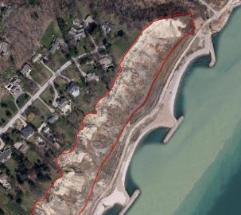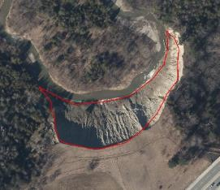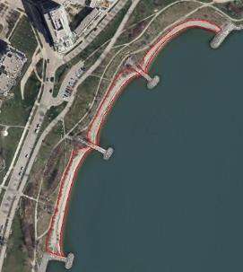

**NCF: Natural Cover - Forest**

Treed areas with greater than 60% tree cover. There is no distinction between coniferous, deciduous or mixed species. Plantations are also included and not distinguished. Open areas smaller than 0.5ha are not isolated.

Hedgerows/windbreaks of less than 4 trees wide are not included in order to allow for a more accurate calculation of patch metrics (size and shape) used in the TNH modelling. Forest areas must **not** show evidence of being manicured (see Recreational/Open Space); and have full or almost full canopy coverage.

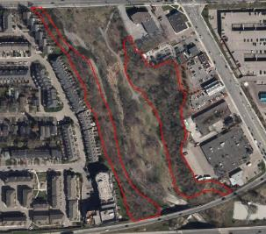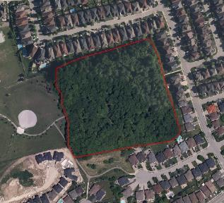

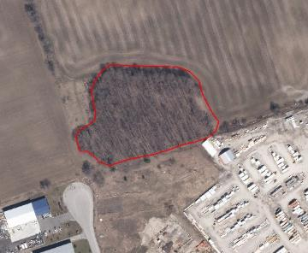

**NCM: Natural Cover - Meadow**

Comprised of a minimum of 50% herbaceous (non-woody) cover, less than 25% tree cover, less than 25% shrub cover and the total coverage of trees and shrubs is less than 50%. Roadside ditches are also included in this category, if they show signs of meadow cover.

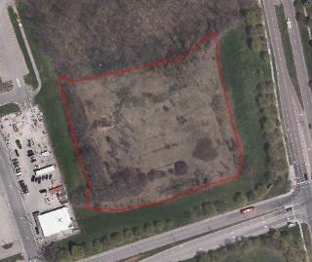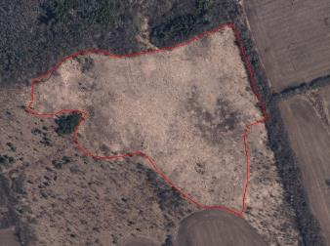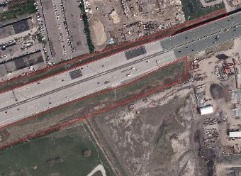

**NCS: Natural Cover - Successional**

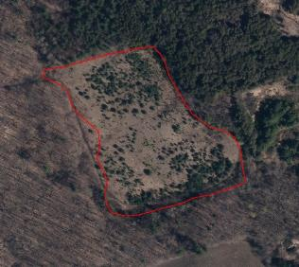These areas are identified by having a composition of 25% - 60% tree cover, 25% - 50% shrub cover. Trees can be a range of all age classes but are sufficiently sparse and/or immature that no distinct canopy has been established as is representative of ‘natural succession’. Orchards and young plantations are included in this classification. Successional areas must **not** show evidence of being manicured. Open areas smaller than 0.5ha are not isolated.

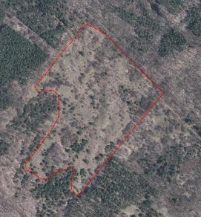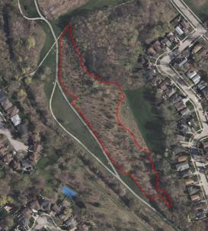

**NCW: Natural Cover - Wetland**

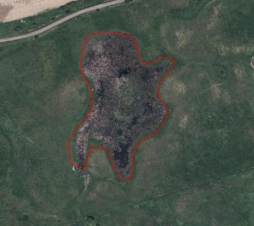Wetlands are distinguishable by the presence of specific vegetation types (terrestrial and/or emergent and/or submergent), and/or visible moisture (open water and/or soil/ground colour changes). The boundary should encircle all of these features when present **except** open water where there is no visible vegetation (see Open Water – Lacustrine). Farm ponds, stormwater ponds, reservoirs etc. are not considered wetlands unless there is appropriate vegetation accompanying the feature to be considered habitat. No size minimum is used as these features can be significant even when very small.

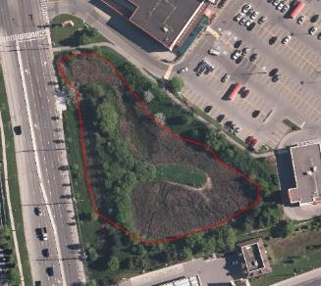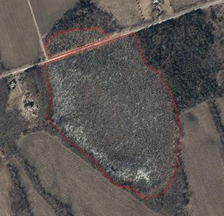

**OWL: Open Water - Lacustrine**

This includes all ponds, lakes and reservoirs including those that are natural, man-made, controlled, on-line, off-line, SWM ponds, irrigation ponds, farm ponds etc. The only open water that is not captured is that which is considered wetland due to the presence of visible vegetation (see Natural Cover – wetland). The boundary of the waterbody should be placed where the shoreline is seen to be or can be reasonably assumed to be. In cases where the shoreline isn’t clear the boundary should be placed at the edge of the open water and should then be coincident with whatever the neighboring landuse is determined to be.

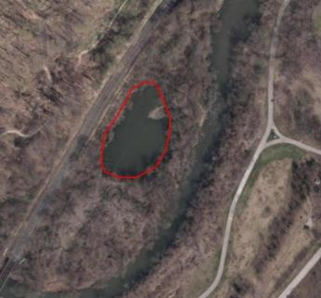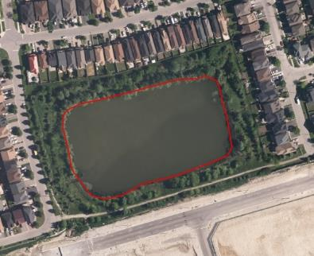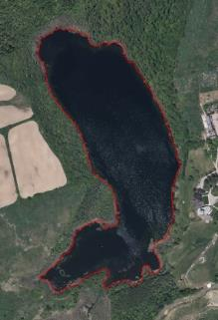

**OWR: Open Water – Riverine**

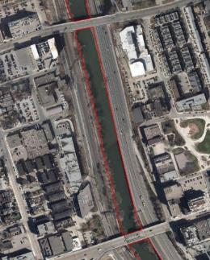This includes all watercourses that are visible using orthophoto interpretation. No Minimum size is used, but given the scale of the collection (around 1:2000), this class includes mostly major watercourses as opposed to minor creeks and streams. The boundary of the river should be placed where the riverbank is seen or can be reasonably assumed to be. Sections of river where the shoreline cannot be discerned due to visual obstruction (tree canopy, urban development, etc.) such that the riverbank cannot be reasonably assumed are classified in accordance with the adjacent landuse class.

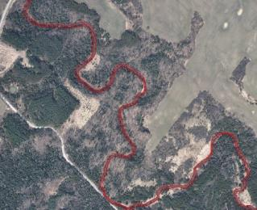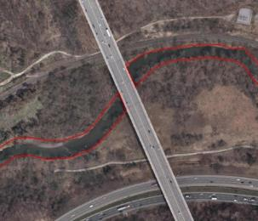

**RDS: Roads**

Roads were restricted to 400 series highways, other major highways, concession or regional roads and roads that are consistently 4 lanes wide. On and off ramps are included as part of this category. The edge of the roadway is considered to be the edge of the gravel or paved shoulder if present, the edge of the pavement or concrete if no shoulder. Sidewalks should only be included if there is less than 1-2m separating the road or shoulder edge from the sidewalk. Bus stations are included as part of this category. Significant impervious areas within cloverleaves were separated out into a more appropriate category, such as Open Space (REC) or Meadow (NCM).Note: Local roads were not classified as separate entities but were instead incorporated without preference into adjacent land classification units.

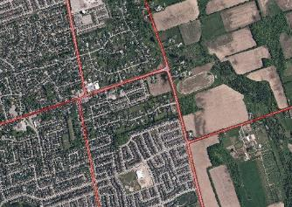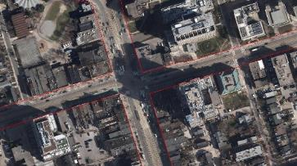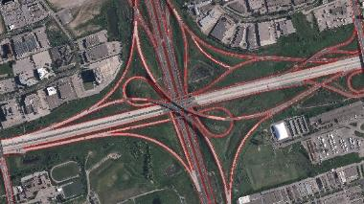

**REC: Recreational and Open Space**

This class is represented by landuses of manicured, semi-manicured or maintained urban areas. This will include parkland, parkettes and recreation-specific facilities such as a recreation centre, ‘sportsplex’, ski hill or a single play area (playground, baseball diamond, soccer field, track, etc.) which are often adjacent to an ‘institutional’ facility or as part of a ‘residential’ complex/development. These include treed areas with evidence of grounds-keeping, open park areas, school yards, large boulevards and hydro towers. Trailer parks and campgrounds are included. Small to medium sized buildings that appear to be part of the recreational area/facility should be included.

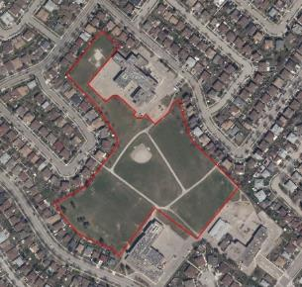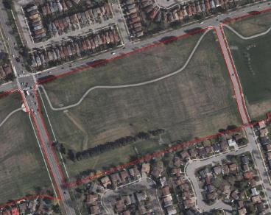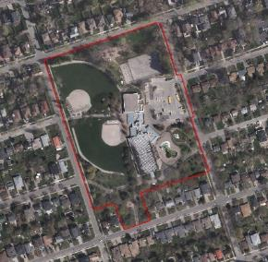This class does not include indoor recreational facilities such as arenas (hockey or curling), laser tag, indoor mini-golf, bowling, etc. These activities often take place amongst commercial or industrial developments so they should be included there.

**RUR: Rural Residential**

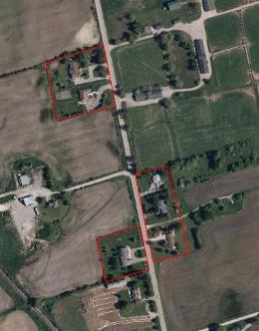Very low to low density detached residential parcels located within the rural landscape often with long private drives (sometimes circular or drive-through near the house) usually located off of concession roads or regional roads with at least several of the following additional criteria: large manicured lawn areas, small to large sized homes, private recreational areas (eg. tennis court, pool, patio, deck), additional buildings such as a workshop or garage or decorative landscaping. These properties are often surrounded by agriculture or natural cover or can be nested within a natural cover setting.

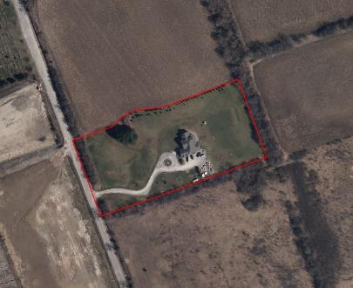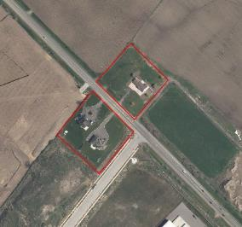

**RWY: Railway**

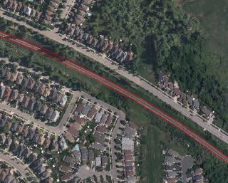Rail lines were identified using visual interpretation. Railway transfer stations or yards and train stations were included in this category. Train stations include parking lot, sidewalks, boulevard, platforms, “kiss-and-ride” drop-off/pickup areas and other paved or developed areas associated with the facility. Small, dedicated access rail lines in industrial areas were not included in ‘railway’ but were instead included in the ‘industrial’ class.

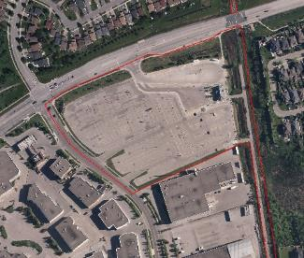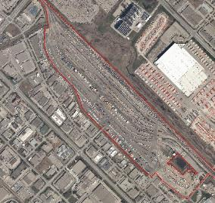

**VAL: Vacant Lands**

Areas of the landscape that have been stripped prior to construction or are currently under construction and active fill sites. Individual parcels or small scale development or redevelopment within an existing ‘developed area’ should not be captured. This class is intended for subdivision level/scale “urban sprawl” and large inner city redevelopments.

